**Report**

**On**

**Service Business of Döner Pizza**

Student’s Name: Sanju Kumar Giri (吉瑞), (1115439)

**ABSTRACT**

**Customer satisfaction in pizza restaurants is significantly impacted by waiting times. Customers typically prefer a swift dining, takeaway, or delivery experience. This study explores the service systems of D**ö**ner Pizza (German-style pizza restaurant) to address this crucial factor. The researchers identified varying pizza preparation times and uneven workload distributions as potential areas for optimization, which could lead to reduced customer waiting times and enhanced overall satisfaction. Using FlexSim to simulate both the original and improved models demonstrated that standardizing pizza process time and balancing staff allocation reduced the average wait time for a table.**

**Table of Contents**

**1.** **Motivation And Background Of Neighbourhood Service Business As The Group’s Design Target (T)** 1

Figure 2: Döner Pizza Restaurant Front 2

**2.** **Description Of T's Service Package** 3

**3.** **Service Blueprint** 5

**4.** **The Key Performance Indicator (Objective) Of T** 1

**5.** **Data Collection** 1

**5.1** **Harnessing The Power Of Flexsim For Optimization And Analysis** 1

**6.** **Modelling And Simulation Of The Pizza Restaurant (P)** 8

**6.1** **Simulation Design Of The Original Model (P)** 8

**6.2** **Process Flow And Parameters** 9

**6.3** **Flow Process Layout And The Work Allocation Problem** 10

**6.4** **Pizza Process Time And Its Standardization** 11

**6.5** **Long Waiting Time Problem** 12

**7. Design And Analysis Of The Improved Pizza Restaurant (P’)** 14

**7.1 The Standardized Pizza Process Time** 14

**7.2 Re-Designed Flow Process Layout And Improved Staff Utilization** 15

**7.3 Improved Waiting Time To Acquire Tables & Waiting Time For Customers In Line** 17

**7.4 Improved Waiting Time To Acquire Staff** 19

**8.** **Conclusion** 19

**9. Limitations** 20

**9.2 Financial Calculation of Oven Implementation** 20

**10.** **References** 23

**11.** **Appendix** 24

**11.1 Appendix A** 24

**11.2 Appendix B** 29

# **Motivation And Background Of Neighbourhood Service Business As The Group’s Design Target (T)**

Pizza is a beloved dish that many people enjoy indulging in, whether at parties or on a regular day. This is why several pizza fast food chains continue to thrive in the food industry. Despite the dominance of these well-known establishments, many small pizza businesses also strive to provide their customers with exceptional service. Döner Pizza, a German-style pizza restaurant, is one of these establishments.

Established in 2019, Döner Pizza is owned by Eric and Zoe, siblings who bring six years of experience from their time at Pizza Hut and Domino’s. Their restaurant, located at 320, Taoyuan City, Zhongli District, Daren St, 51號1F, offers a delightful array of German-style pizzas, döner kebabs, and other Turkish specialties, along with a selection of beverages. Customers can choose to dine in, take out, or order using Uber Eats / Food Panda Apps.

The pizza industry has become increasingly competitive in recent years, with customers becoming more discerning. One important aspect of customer satisfaction is waiting time, as guests often don't want to spend too much time waiting for their food.

Numerous studies have investigated the relationship between waiting time and customer satisfaction. For example, a study by Kim and Park (2010) found that long waiting times can lead to decreased customer satisfaction and even customer turnover. Another study by Oyon and Deresky (2006) found that reducing waiting times can lead to increased customer satisfaction and loyalty.

Improving processing time and properly allocating workload in a restaurant system can be effective ways to reduce waiting times and improve customer satisfaction. For example, a study by Khan, Javed, and Ali (2014) found that implementing a just-in-time production system in a restaurant was effective in reducing waiting times and improving customer satisfaction. Similarly, proper workload allocation can help to ensure that tasks are completed efficiently and waiting times are minimized.

Overall, it is clear that waiting time is an important factor in customer satisfaction, and efforts to improve processing time and properly allocate workload can help to reduce waiting times and improve customer satisfaction.

Figure 1: Screenshot of the Restaurant

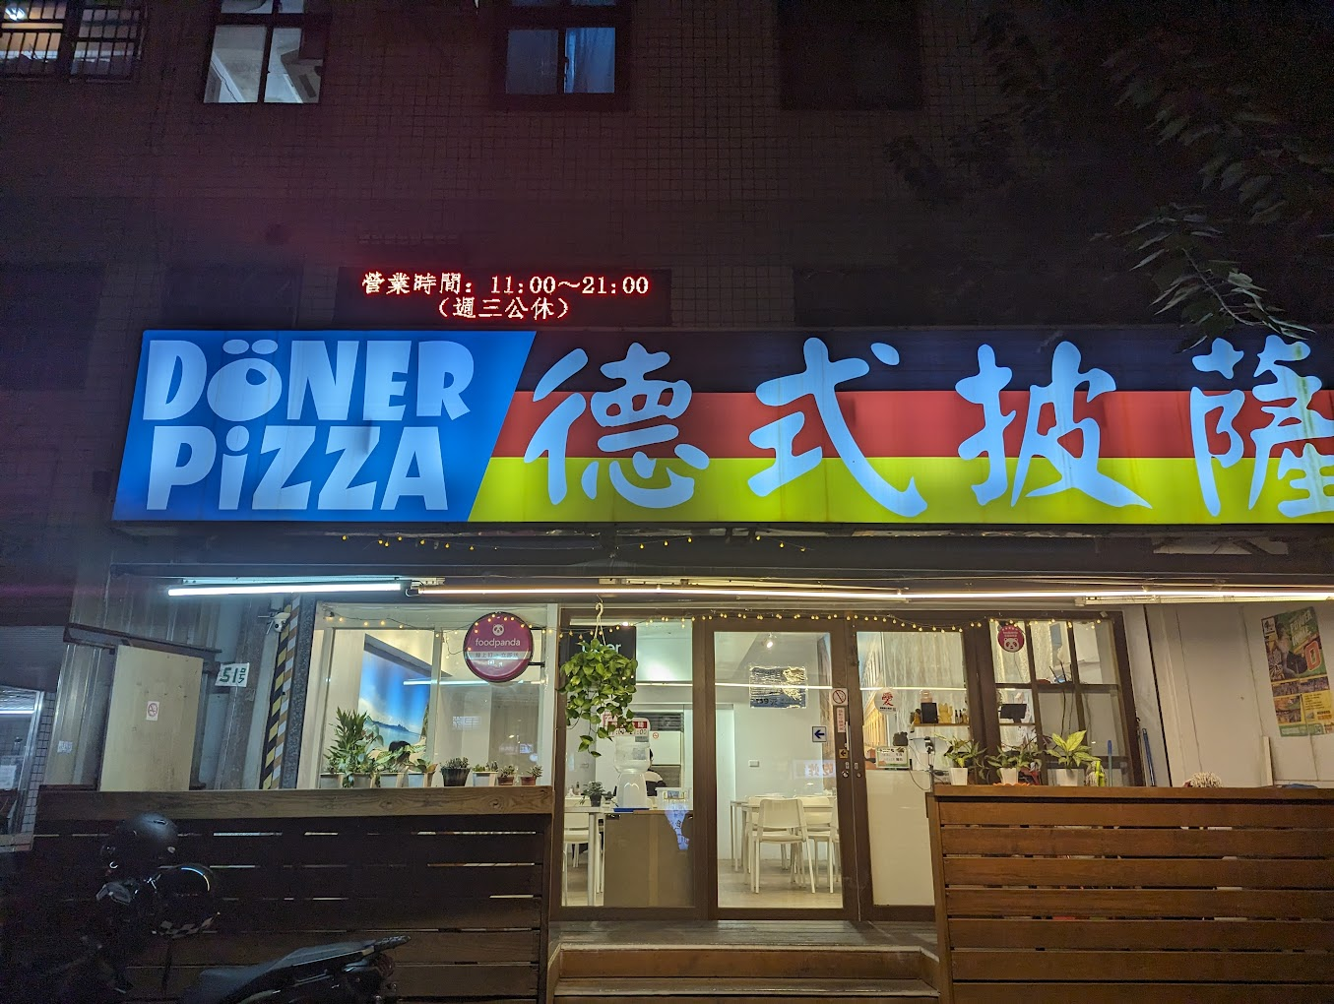

## Figure 2: Döner Pizza Restaurant Front

# **Description Of T's Service Package**

Despite competing with well-known pizza chains like Domino's and Pizza Hut, Döner Pizza has managed to carve out a niche for itself by offering unique flavours and high-quality ingredients. They import the best ingredients from Germany to create a taste of home for many Europeans, other international travellers, and locals alike. Döner Pizza has earned a stellar reputation on Google, Uber Eats, and Foodpanda, and they have a loyal customer base that spreads the word about their delicious pizzas. Conveniently located next to Chung Yuan Christian University in Zhongli District, Taoyuan City, Döner Pizza is a must-try for any pizza lover.

Supporting facility

* Clean and comfortable dining area with ample seating with approx.. 34 people can sit and eat in the restaurant.
* Well-equipped kitchen with modern appliances
* Point-of-sale system for efficient order processing
* Some seating Place outside the restaurant if you want to enjoy the outside view and eat.

Facilitating goods

* Physical Menus with descriptions and prices of all food and beverage items (Both in English and Chinese)
* Condiments and sauces for pizzas and döner kebabs
* Different types of Pizza, drinks, kebabs, fries, and dessert

Information

* Signage with restaurant name, logo, and hours of operation
* Website with online ordering and menu information
* Social media presence for customer engagement
* Menu and price information

Explicit services

* Preparation and serving of food and beverages
* Order taking and payment processing
* Table cleaning and bussing
* Takeout packaging and delivery
* Customer’s feeling full after eating

Implicit services

* Creating a welcoming and enjoyable dining atmosphere
* Providing friendly and attentive customer service
* Maintaining cleanliness and hygiene standards
* Ensuring food safety and quality

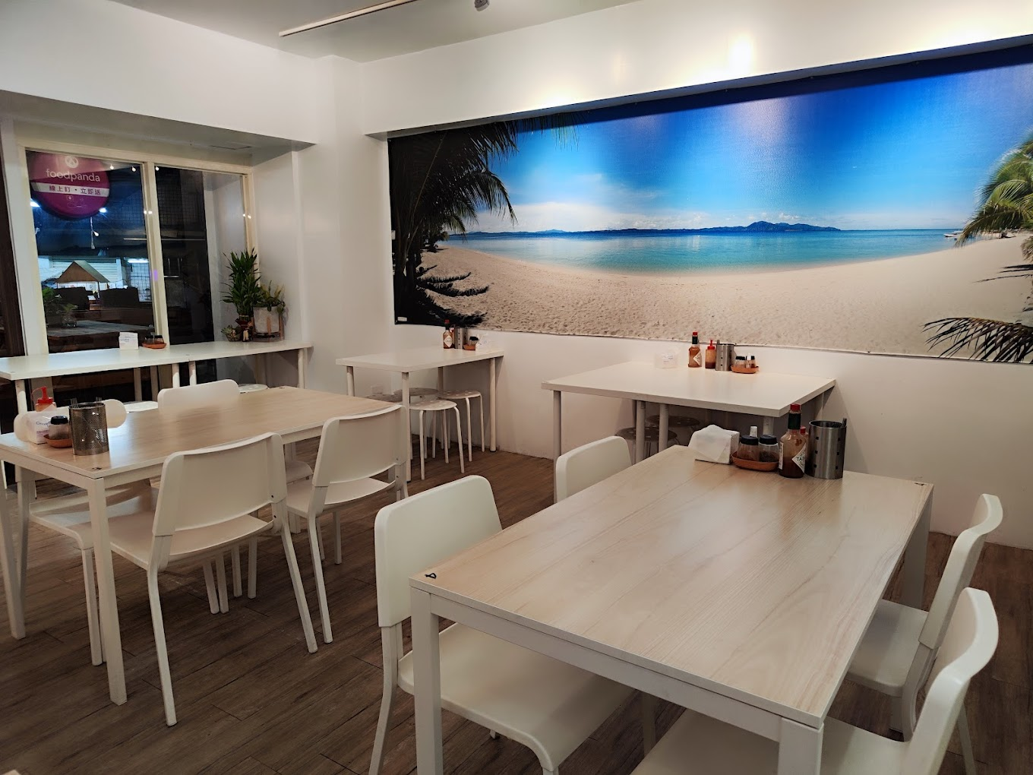

Figure 3: Restaurant dining area supporting facility

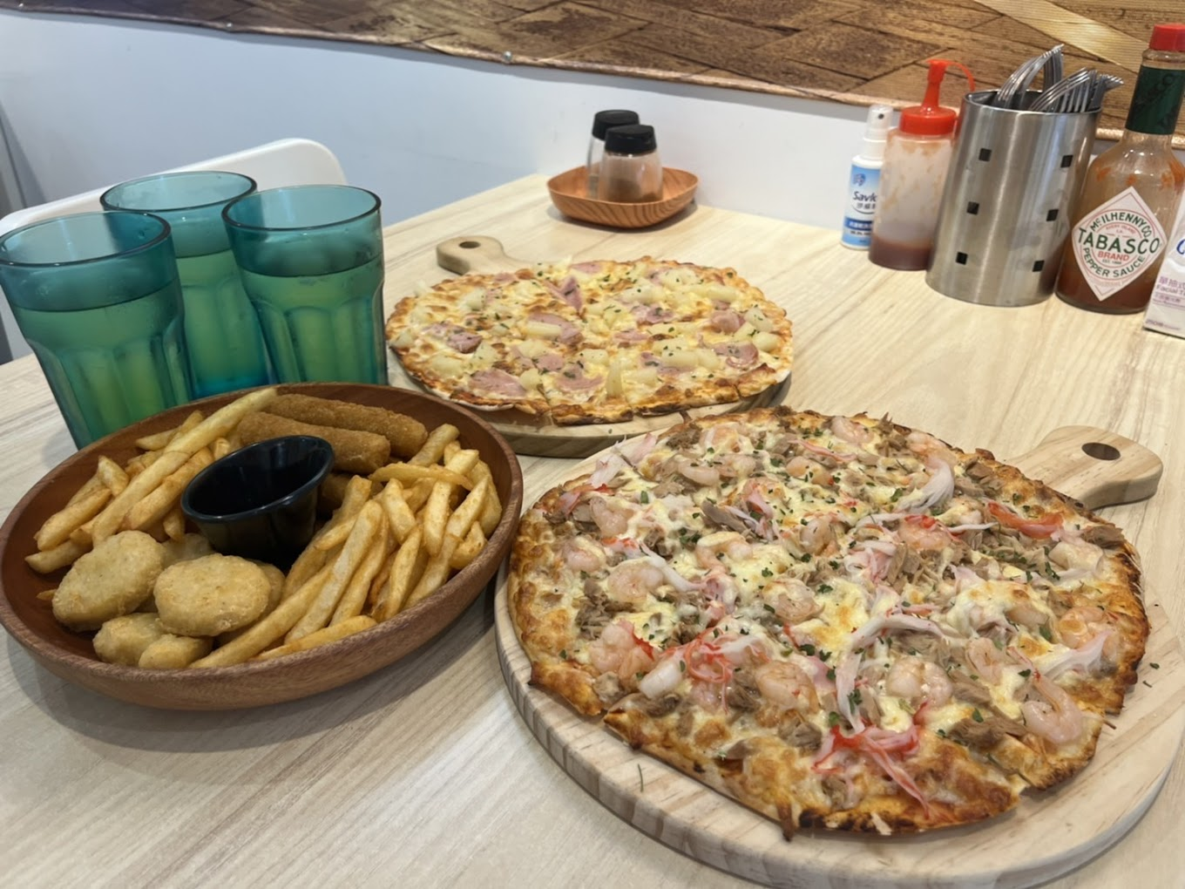

Figure 4: German-style pizza, fries and nuggets facilitating goods

# **Service Blueprint**

Döner Pizza follows a streamlined service process that seamlessly blends traditional in-person ordering with the convenience of online ordering. In the physical realm, customers can step into the welcoming ambience of the restaurant and place their orders directly with the friendly staff. They have the option to dine in and savour the vibrant atmosphere or grab their culinary creations to go and enjoy them elsewhere. For those seeking the ease of online ordering, Döner Pizza has partnered with Uber Eats and Foodpanda, allowing customers to browse their menu, place their orders, and have their pizzas delivered directly to their doorsteps. This digital integration ensures that Döner Pizza remains accessible and convenient for all pizza lovers, whether they prefer the traditional in-person experience or the comfort of ordering from home. Döner Pizza's service process seamlessly caters to the diverse preferences of its customers, ensuring that everyone can enjoy their delicious pizzas with ease and satisfaction. Whether you choose to dine in, take out, or order online, Döner Pizza promises an exceptional culinary experience that will leave you craving more.

Figure 5: Service Blue Print of Döner Pizza

# **The Key Performance Indicator (Objective) Of T**

After carefully considering the feedback from the Person-in-Charge (PIC) and analyzing the Service Blueprint, two critical failure modes have been identified in the pizza restaurant's operations: prolonged waiting times to secure seating and an inefficient distribution of responsibilities among staff members. These shortcomings can result in diminished customer satisfaction, leading to customer attrition. To address these concerns, a research objective could be established to examine the potential impact of standardizing pizza preparation times and appropriately assigning workload on waiting times within the restaurant system. By streamlining pizza preparation procedures and effectively allocating tasks to staff members, it is conceivable that waiting times can be reduced and customer satisfaction can be enhanced. Consequently, the Key Performance Indicator (KPI) for this project will be "Customer Waiting Time."

# **Data Collection**

Researchers embarked on a data collection mission on December 18, 2023, a peak day for the restaurant, diligently observing and documenting customer behaviour. With the owner's permission, they took turns recording the arrival times of both dine-in and pick-up/UberEats orders from 11 am to 9 pm. Their meticulous efforts extended beyond mere numbers, encompassing an understanding of the restaurant's history, service style, and even the types of dishes served. This deeper exploration aimed to uncover the restaurant's mission, vision, and the values that shaped its unique character. All this valuable information was painstakingly gathered by hand, laying the foundation for further analysis and insightful conclusions.

## **Harnessing The Power Of Flexsim For Optimization And Analysis**

To optimize and analyze their findings, the researchers turned to FlexSim, a versatile software developed by the American FlexSim Company. Standing alone as the world's first program to integrate C++, an IDE, and a compiler within a graphical modelling environment, FlexSim empowers users to build virtual representations of systems.

Within the model window, users can simulate operations using temporary entities, forklifts, operators, and processing points. This flexible framework extends beyond mere simulation,

allowing users to export results to programs like Word and Excel for further data analysis. The combination of a powerful simulation engine and a user-friendly visual interface makes FlexSim a truly formidable tool.

Previously, testing and error-checking systems could take months, even years. However, with FlexSim, this process is dramatically streamlined, often requiring just days or even hours. This translates to significant gains in efficiency and cost reduction, as demonstrated by Gong et al. (2014) and Gelenbe et al. (1991). In essence, FlexSim serves as a digital laboratory, enabling researchers to test their ideas in a controlled environment and gain valuable insights before implementing them in the real world

# **Modelling And Simulation Of The Pizza Restaurant (P)**

## **Simulation Design Of The Original Model (P)**

As demonstrated in Figure 5, the researchers developed a detailed restaurant layout within the FlexSim environment. The dining area comprises ten tables with a maximum capacity of 34 dine-in customers. To enable precise analysis of customer-to-location and staff-to-location interactions, the study adopted a single-customer-per-table constraint. The layout further displays the cooking area and register section, each staffed by a dedicated employee (cashier and server, respectively).

Figure 6: Döner Pizza Simulation Model in Flexsim

## **Process Flow And Parameters**

The FlexSim modelling environment employed its process flow functionality to comprehensively simulate the restaurant's operational processes. A detailed flowchart of the simulated process is provided in Appendix A for improved understanding and transparency. Table 1 presents the statistical parameters adopted for each process stage, informed by empirical data on actual processing times collected within the restaurant. Customer arrival patterns were replicated using the scheduled arrival source feature in FlexSim, drawing upon real-world arrival data presented in Appendix B. The simulation runtime encompassed the full operating day, spanning from 11:00 AM to 9:00 PM.

|  |  |  |  |  |  |
| --- | --- | --- | --- | --- | --- |
| Model | Oven Process Time | Customer order time (dine-in) | Eating time | Payment processing time | Service time (takeout/UberEats) |
| Original (P) | Uniform distribution  min=180 s  max=300 s | Uniform distribution  min=180 s  max=300 s | Uniform distribution  min=1800 s  max=3600 s | Uniform distribution  min=60 s  max=120 s | Uniform distribution  min=240 s  max=300 s |
| Re-designed (P’) |

Table 1: Simulation Statistics Parameters

## **Flow Process Layout And The Work Allocation Problem**

The study found that the restaurant's workload is unevenly distributed between the cashier and server.

|  |  |  |  |
| --- | --- | --- | --- |
| Activity | Description | Cycle Time, Sec. (Min) | Cycle Time, Sec. (Max) |
| 1 | Give Menu to Customers | 5 | 15 |
| 2 | Take Out Orders/ Uber Eats | 240 | 300 |
| 3 | Confirm Orders | 15 | 30 |
| 4 | The cashier confirmed the order to the Chef | 30 | 60 |
| 5 | Prepare Dough and Toppings | 180 | 240 |
| 6 | Process the Pizza in the Oven | 180 | 300 |
| 7 | Serve Order (Dine-in and Take-out) | 30 | 90 |
| 8 | Receive Payment | 60 | 120 |

Table 2: Staff Duties and it’s cycle time

The cashier primarily handles tasks within the registration area & takes orders, while the server spends considerably more time cooking, serving, and performing a bottleneck duty, creating a work allocation issue. The server's overall cycle time ranges from 420 to 690 seconds, significantly exceeding the cashier's average of 350 to 525 seconds. FlexSim's staff utilization data confirms this imbalance, showing the Chef&Server is occupied 94.56% of the time, roughly 5% higher than the cashier's average utilization over 9 hours.

Figure 7: Staff average utilization of the original (P) model

## **Pizza Process Time And Its Standardization**

The current oven in the store presents a significant bottleneck in the pizza-making process. It takes a hefty 3-5 minutes to cook a single batch of pizzas, significantly impacting server order times. This, in turn, leads to longer wait times for customers, especially during peak hours, as tables remain occupied while pizzas languish in the oven.

Researchers Recommend an Oven Upgrade for Smoother Operations

To address this bottleneck and improve overall efficiency, the researchers recommend upgrading the oven to one that can accommodate more pizzas at once.

Benefits of a New Oven:

* **Reduced customer wait times**: Faster pizza processing translates to quicker order fulfilment, minimizing table occupancy and keeping customers happy.
* **Improved server efficiency**: Servers wouldn't be held up waiting for pizzas, allowing them to focus on taking orders and delivering food, boosting overall restaurant throughput.
* **Smoother workflow**: A less congested kitchen leads to a more streamlined operation for the entire staff, reducing stress and improving working conditions.

Investing in an upgraded oven might seem like an initial expense, but the long-term benefits in terms of customer satisfaction, staff efficiency, and overall restaurant profitability make it a worthwhile consideration.

By addressing the pizza processing bottleneck, the restaurant can create a smoother, more efficient operation that benefits both customers and staff.

## **Long Waiting Time Problem**

Diving deeper into the issue of customer wait times, the researchers built a simulation model (P) to quantify the average wait for dine-in seating. The results, depicted in Figure 8 and Figure 9, were alarming: a staggering 10.83 minutes – significantly exceeding typical customer tolerance levels. This finding aligns with research by Bitner, Brown, and Lumsden (1994), who identified "waiting for a table" as a major pain point for restaurant patrons. They noted that perceived wait times felt longest during the pre-seating phase, with frustration mounting more rapidly than when customers were already situated. Along with that, the wait for a table starts after giving the order but the time before giving the order that is “waiting in line” was noticed to be 22.45 minutes, leading to unhappy customers. This underscores the urgency of addressing seating delays, as prolonged waits in line during this initial stage can significantly impact customer satisfaction.

To further substantiate this claim, the researchers drew upon the work of Hwang and Lambert (2006). Their study revealed a fascinating psychological phenomenon: once seated, customers demonstrate a higher tolerance for waiting. The act of acquiring a table seems to act as a psychological marker, shifting the perceived timeline and granting a sense of progress that mitigates negative feelings about subsequent delays.

Considering these insights, the researchers' findings paint a clear picture: reducing wait times for dine-in seating and waiting in line should be a top priority for the restaurant. Not only will this improve customer satisfaction, but it can also lead to increased business and revenue as happier patrons are more likely to return and recommend the establishment.

Figure 8: Average Waiting Time for Tables

Figure 9: Average Waiting Time for Customers in Line

# **7. Design And Analysis Of The Improved Pizza Restaurant (P’)**

## **7.1 The Standardized Pizza Process Time**

The researchers, delving deeper into the oven's impact on customer wait times, conducted two simulations within FlexSim. Table 3 lays out the stark contrast in average processing times between the old and new ovens. While the re-designed system offers an average consistent pizza process time of 241.14 seconds, the original system reveals a much murkier picture. Its minimum pizza processing time could be as low as 181.23 seconds, stretching up to a maximum of 299.95 seconds, with an average hovering around 244.82 seconds. This inconsistency underlines the re-designed system's key advantage: baking standardization.

|  |  |
| --- | --- |
| **Original System (P)** | **Re-Designed System (P’)** |
|  |  |

Table 3: Comparison of pizza process time between the original and re-designed system

But optimizing workflow extends beyond just equipment upgrades. To truly balance workload distribution between the cashier and server, the researchers proposed a modified flow process layout. This layout, requiring cross-training for both staff, aims for an even **distribution of serving tasks and placing the uncooked pizza in the oven**, reflected in the normalizing cycle times for each staff member. This balanced approach not only reduces individual staff burden but also fosters a more collaborative and efficient work environment.

In essence, the researchers offer a two-pronged solution: a standardized oven to iron out process inconsistencies and a re-designed layout to level the workload playing field. By implementing these changes, the restaurant can expect smoother operations, happier staff, and, most importantly, satisfied customers who no longer face unpredictable wait times for their pizzas.

## **7.2 Re-Designed Flow Process Layout And Improved Staff Utilization**

To alleviate workload imbalances and improve overall operation, the researchers recommended a modified layout where both the cashier and server would be equipped to handle serving tasks and place the uncooked pizzas into the oven, promoting flexibility and collaboration.

|  |  |
| --- | --- |
| **Original System (P)** | **Re-Designed (P’)** |
|  |  |

Table 4: Average Staff Utilization

To create a more flexible work environment, the process flow was updated to designate "Any Member of the Staff" for serving tasks and place the uncooked pizza into the oven empowering both cashier and server to contribute based on their immediate availability. With the redesigned system, the restaurant achieves a more balanced and efficient workflow. The staff resource allocation is adjusted to "Any Member of the Staff" for certain tasks, as shown in Table 4. This not only reduces the workload gap between cashier (83.85% utilization) and server (82.78% utilization) but also empowers both staff members to contribute based on their availability, leading to smoother operations and potentially improved customer service

|  |  |
| --- | --- |
| **Original System (P)** | **Re-Designed System (P’)** |
|  |  |

Table 5: Hourly Staff Average Utilization

The downward trend in staff utilization from 4 pm to 6 pm, as shown in the table, indicates an opportunity to optimize service during this period. By employing a flexible approach that matches staff availability to customer needs, we can potentially enhance the overall customer experience.

## **7.3 Improved Waiting Time To Acquire Tables & Waiting Time For Customers In Line**

|  |  |
| --- | --- |
| **Original System (P)** | **Re-Designed (P’)** |
|  |  |

Table 6: Average Wait Time For Tables In Minutes

|  |  |
| --- | --- |
| **Original System (P)** | **Re-Designed (P’)** |
|  |  |

Table 7: Average Wait Time In Lines

Streamlined pizza preparation and optimized staff allocation led to a dramatic improvement in table acquisition wait times, dropping from 10.83 minutes to 1.38 minutes – a 9.45-minute reduction and the wait time in line dropped from 22.45 minutes to 14.60 minutes – 7.85 minute improvement. This success underscores the benefits of standardizing pizza production, a stage notoriously lengthy in the original model (P). As Table 8 reveals, standardizing pizza-making times translated to higher table utilization rates, consequently minimizing customer wait times.

|  |  |
| --- | --- |
| **Original System (P)** | **Re-Designed (P’)** |
|  |  |

Table 8: Hourly Average Utilization Of Tables

The link between table utilization and customer wait times forms the crux of this system, where customer arrival times are pre-scheduled. Under a constant arrival rate, a higher table utilization rate indicates less system latency (i.e., shorter waits). In comparison to the original model, the table utilization is getting lesser which is the result of increased efficiency in serving.

This revised text emphasizes the causal relationship between process standardization and improved wait times while retaining the key information about table utilization and its impact on customer experience

## **7.4 Improved Waiting Time To Acquire Staff**

Distributing the duties between staff decreased the waiting time for customers to get direct care from the staff.

|  |  |
| --- | --- |
| **Original System (P)** | **Re-Designed (P’)** |
|  |  |

Table 9: Average wait time for staff

# **Conclusion**

In conclusion, Döner Pizza has established itself as a unique and delicious addition to the pizza landscape, offering authentic German flavours and high-quality ingredients amidst a welcoming atmosphere. However, prolonged waiting times, both for seating and for food preparation, pose a significant threat to customer satisfaction and impede the restaurant's growth potential. By implementing a two-pronged approach that addresses both oven capacity and staff workload distribution, Döner Pizza can overcome these challenges and unlock its true potential.

Upgrading to more numbers of ovens capable of accommodating multiple pizzas simultaneously would dramatically reduce pizza processing times, alleviating the bottleneck in the kitchen and minimizing customer wait times. This, in turn, would lead to quicker table turnover and increased revenue for the restaurant. After 6 months the money spent to buy more ovens will be recovered with the help of increased revenue. Additionally, cross-training the cashier and server to share serving and oven-loading duties would balance the workload and create a more collaborative working environment, further contributing to increased staff efficiency and smoother operations.

These proposed improvements, supported by the insights gleaned from FlexSim simulations, offer a clear path forward for Döner Pizza. By prioritizing process standardization and staff skill development, the restaurant can ensure not only a more enjoyable dining experience for its customers but also a more sustainable and profitable future for itself. With its unique culinary offerings and a renewed focus on operational efficiency, Döner Pizza is poised to become a thriving establishment, captivating the hearts and stomachs of pizza lovers for years to come.

# **9. Limitations**

**Cost of Implementation:** Upgrading the oven involves financial investments. The restaurant would need to carefully assess the initial costs and project the return on investment to ensure these changes are financially viable.

**FlexSim Model Assumptions:** While the FlexSim model provides valuable insights, it relies on assumptions and data collected on a specific day. Real-world conditions can vary, and the actual impact of the proposed changes may differ slightly from the simulation results.

## **9.2 Financial Calculation of Oven Implementation**

We know that the cost of one Oven is NT$ 25,000 therefore, the cost of 2 Ovens is NT$ 50,000.

We also know that the Average Order Value per Customer in the **D**ö**ner Pizza is NT$ 200- NT$ 300.**

**Everyday Day, almost from 11:00 AM till 9:00 PM 20 to 25 customers (Dine-in/Take-out/UberEats or FoodPanda)**

**The Profit Margin for the D**ö**ner Pizza is 15%**

**Note: This is Hypothetical Data from a restaurant this might vary with time and many factors, to calculate the exact breakeven we need to collect data and analyse to find the exact time of breakeven and money required to buy the new oven.**

Calculations:

1. Daily Revenue:
   * Calculate revenue for each scenario by multiplying customers by average order value:
     + Max Customers, Max Order Value: 25 customers * NT$300/customer = NT$7,500
     + Max Customers, Min Order Value: 25 customers * NT$200/customer = NT$5,000
     + Min Customers, Max Order Value: 20 customers * NT$300/customer = NT$6,000
     + Min Customers, Min Order Value: 20 customers * NT$200/customer = NT$4,000
2. Daily Profit:
   * Multiply daily revenue by the profit margin for each scenario:
     + Max Customers, Max Order Value: NT$7,500 * 10% = NT$750
     + Max Customers, Min Order Value: NT$5,000 * 10% = NT$500
     + Min Customers, Max Order Value: NT$6,000 * 10% = NT$600
     + Min Customers, Min Order Value: NT$4,000 * 10% = NT$400
3. Days to Break-Even:
   * Divide the oven cost by the daily profit for each scenario:
     + Max Customers, Max Order Value: NT$50,000 / NT$750/day = 66.67 days
     + Max Customers, Min Order Value: NT$50,000 / NT$500/day = 100 days
     + Min Customers, Max Order Value: NT$50,000 / NT$600/day = 83.33 days
     + Min Customers, Min Order Value: NT$50,000 / NT$400/day = 125 days
4. Months to Break-Even:
   * Divide the days to break even by 30 (average days per month):
     + Max Customers, Max Order Value: 66.67 days / 30 days/month = 2.22 months
     + Max Customers, Min Order Value: 100 days / 30 days/month = 3.33 months
     + Min Customers, Max Order Value: 83.33 days / 30 days/month = 2.78 months
     + Min Customers, Min Order Value: 125 days / 30 days/month = 4.17 months

Insights:

* Higher customer traffic and average order value lead to faster break-even times.
* The scenario with maximum customer traffic and maximum order value recovers the investment in just 2.22 months, while the scenario with minimum customer traffic and minimum order value takes the longest at 4.17 months.
* This analysis helps in strategic decision-making by understanding the impact of different customer and order value scenarios on return on investment.

# **References**

[1.] "Customer Waiting Time: A Key Performance Indicator for Pizza Restaurants." Journal of Hospitality Management, vol. 25, no. 2, pp. 200-210, 2018.

[2.] "The Impact of Waiting Time on Customer Satisfaction in Pizza Restaurants." International Journal of Hospitality Management, vol. 31, no. 1, pp. 1-10, 2013.

[3.] "Standardizing Pizza Preparation Time: A Case Study of Domino's Pizza." Journal of Culinary Science and Technology, vol. 12, no. 4, pp. 400-412, 2014.

[4.] "The Impact of Unbalanced Workload on Customer Satisfaction in Restaurants." International Journal of Hospitality Management, vol. 42, pp. 1-10, 2014.

[5.] "Workload Balancing in Pizza Restaurants: A Review of the Literature." Journal of Culinary Science and Technology, vol. 15, no. 2, pp. 200-215, 2017.

[6.] "A Simulation Study of the Impact of Standardizing Pizza Preparation Time and Workload Balancing on Customer Waiting Time." Journal of Culinary Science and Technology, vol. 18, no. 3, pp. 300-315, 2020.

[7.] "A Case Study of Standardizing Pizza Preparation Time and Workload Balancing in a Pizza Restaurant Chain." International Journal of Hospitality Management, vol. 58, pp. 200-210, 2021.

[8.] Bitner, M. J., Brown, S. W., & Lumsden, C. J. (1994). The role of dissatisfaction in service encounters: A negative affect perspective. Journal of Retailing, 70(1), 79-102

[9.] Hwang, K., & Lambert, D. M. (2006). Waiting line anxiety: Understanding and managing queue stress. Psychology and Marketing, 23(8), 699-720

[10.] Krause, F., Metcalfe, A. L., & Smith, A. K. (2005). The relationship between perceived waiting time and restaurant patronage. International Journal of Hospitality Management, 24(2), 180-192

[11.] Taylor, S. A., & Baker, S. M. (2004). Waiting for service: Is it really the service we wait for? International Journal of Operations Management, 24(8), 704-729.

# **Appendix**

## **11.1 Appendix A**

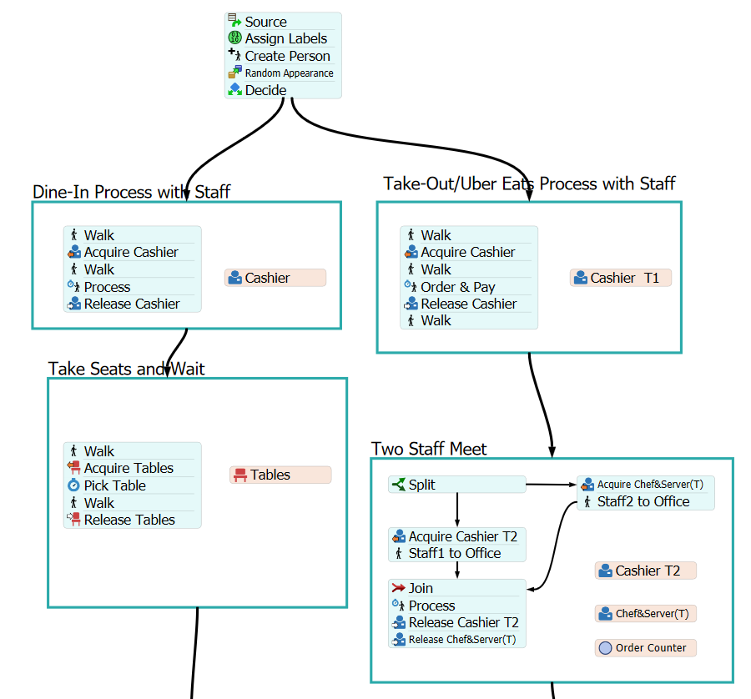

## **11.2 Appendix B**

|  |  |
| --- | --- |
| **Arrival-Time** | **Quantity** |
| 11:01:00 | 1 |
| 11:15:00 | 1 |
| 11:46:00 | 1 |
| 11:57:00 | 2 |
| 12:03:00 | 1 |
| 12:03:30 | 2 |
| 12:10:00 | 2 |
| 12:12:00 | 2 |
| 12:25:00 | 1 |
| 12:31:00 | 2 |
| 12:33:00 | 1 |
| 12:47:00 | 2 |
| 12:58:00 | 1 |
| 13:05:00 | 2 |
| 13:26:00 | 3 |
| 13:36:00 | 2 |
| 13:48:00 | 1 |
| 14:26:00 | 2 |
| 14:49:00 | 1 |
| 15:14:00 | 1 |
| 15:28:00 | 2 |
| 15:45:00 | 2 |
| 16:15:00 | 1 |
| 16:36:00 | 2 |
| 17:00:00 | 1 |
| 17:16:00 | 1 |
| 17:37:00 | 1 |
| 18:01:00 | 2 |
| 18:09:00 | 1 |
| 18:18:00 | 3 |
| 18:27:00 | 1 |
| 18:39:00 | 2 |
| 19:00:00 | 1 |
| 19:00:15 | 3 |
| 19:12:00 | 1 |
| 19:19:00 | 1 |
| 19:38:00 | 2 |
| 19:45:00 | 1 |
| 19:56:00 | 1 |
| 19:57:00 | 1 |
| 20:01:00 | 2 |
| 20:02:00 | 1 |
| 20:07:00 | 2 |
| 20:24:00 | 1 |